Q: Write a program to encrypt and decrypt Plain text using Hill Cipher

Ans:

Source Code:

#include<iostream>

#include<math.h>

using namespace std;

float encmatrix[3][1], decmatrix[3][1], a[3][3], b[3][3], msg[3][1], m[3][3];

void KeyMatrix() {

int i, j;

char mes[3];

cout<<"\nEnter plain text of length 3(use A through Z): ";

cin>>mes;

for(i = 0; i < 3; i++)

msg[i][0] = mes[i] - 65;

cout<<"Enter 3x3 matrix key:\n";

for(i = 0; i < 3; i++)

for(j = 0; j < 3; j++) {

cin>>a[i][j];

m[i][j] = a[i][j];

}

}

void Encrypt() { //encrypts the message

int i, j, k;

for(i = 0; i < 3; i++)

for(j = 0; j < 1; j++)

for(k = 0; k < 3; k++)

encmatrix[i][j] = encmatrix[i][j] + a[i][k] * msg[k][j];

cout<<"\nEncrypted text: ";

for(i = 0; i < 3; i++)

cout<<(char)(fmod(encmatrix[i][0], 26) + 65); //modulo 26 is taken for each element of the matrix obtained by multiplication

}

void inversematrix() { //find inverse of key matrix

int i, j, k;

float p, q;

for(i = 0; i < 3; i++)

for(j = 0; j < 3; j++) {

if(i == j)

b[i][j]=1;

else

b[i][j]=0;

}

for(k = 0; k < 3; k++) {

for(i = 0; i < 3; i++) {

p = m[i][k];

q = m[k][k];

for(j = 0; j < 3; j++) {

if(i != k) {

m[i][j] = m[i][j]*q - p*m[k][j];

b[i][j] = b[i][j]*q - p*b[k][j];

}

}

}

}

for(i = 0; i < 3; i++)

for(j = 0; j < 3; j++)

b[i][j] = b[i][j] / m[i][i];

cout<<"\n\nInverse Matrix:\n";

for(i = 0; i < 3; i++) {

for(j = 0; j < 3; j++)

cout<<b[i][j]<<" ";

cout<<"\n";

}

}

void Decrypt() { //decrypt the message

int i, j, k;

inversematrix();

for(i = 0; i < 3; i++)

for(j = 0; j < 1; j++)

for(k = 0; k < 3; k++)

decmatrix[i][j] = decmatrix[i][j] + b[i][k] * encmatrix[k][j];

cout<<"\nDecrypted text: ";

for(i = 0; i < 3; i++)

cout<<(char)(fmod(decmatrix[i][0], 26) + 65); //modulo 26 is taken to get the original message

cout<<"\n";

}

int main() {

KeyMatrix();

int n;

Encrypt();

cout<<"\nEnter 1 to Decrypt and 0 to exit.\t";

cin>>n;

if(n){

Decrypt();

}

return 0;

}

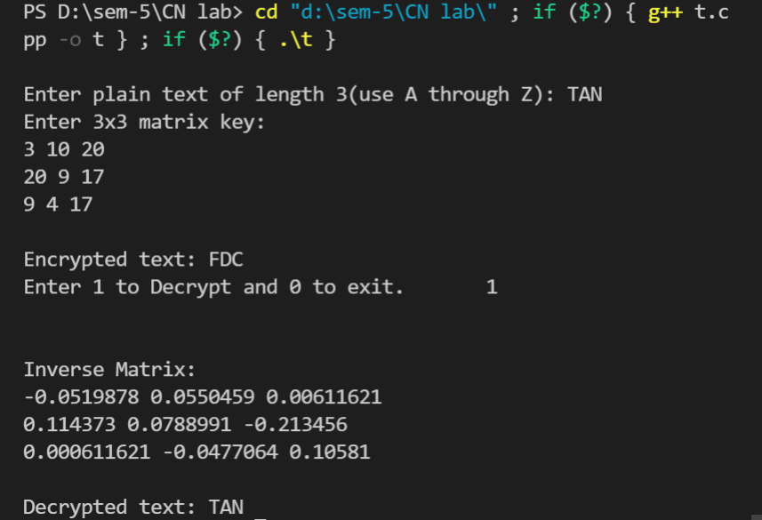
Output:

